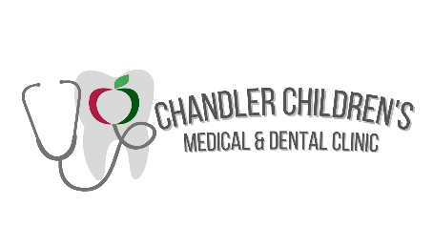

Become a committee volunteer for the

Chandler Children’s Medical and Dental Clinic

Established in 1995, the Chandler CARE Center is a school-based family resource center providing access to medical, dental, counseling, and social services. Most services are free of charge to families thanks to the many funders, professionals, and service organizations contributing financially and volunteering their services.
Dental Services Provided Include:
- Cleanings
- Fluoride varnish
- Dental sealants to protect teeth
- Oral hygiene education
- X-rays
- Referrals for restorative treatment
Chandler Children's Medical Clinic:
- basic pediatric services
- chiropractic care
- well-checks
- treatment of minor illness or injury
- sports physicals for CUSD athletes
- care for some chronic and co-occurring diseases and disorders.

The Chandler Children's Medical Clinic is a partnership with volunteer medical providers, ensuring access to no-cost medical care and treatment for youth.
The Chandler Children’s Medical and Dental Clinic is looking for volunteers who have a background in Marketing, PR, and Social Media promotion. Our Marketing and Fundraiser committee is actively working on developing new materials to present to the public to educate them about all the amazing services offered at the Chandler CARE Center and the Chandler Children’s Medical and Dental Clinic inside.

How can I participate:
Send an email to the director at the Chandler CARE Center. Please include best way to contact you and how you feel you can benefit the team. We are looking for those that have a passion to give back with their skillsets and network. Please email: Kahle.Katie@cusd80.edu
What is expected:
Marketing Committee is responsible for:
- All print and online marketing aspects to promote the organization, mission, and events
- Monthly/Quarterly Press Releases to educate the community on mission and current events
- Participation in networking events virtually or in person when permitted
- Committee members are expected to maintain reasonable attendance 80%
  - Meetings will be held at least once every 8 weeks: More frequently as needed
On Behalf of the Board of Trustees, the Staff, and the families we help, we would like to thank you for your consideration to volunteer your time to our organization. With your support, we can make kids feel safe and healthy every day and parents feel a comfort knowing their community supports them.
Thank you in advance for your consideration.
Jennifer Bertoldo
Board of Trustees Present

